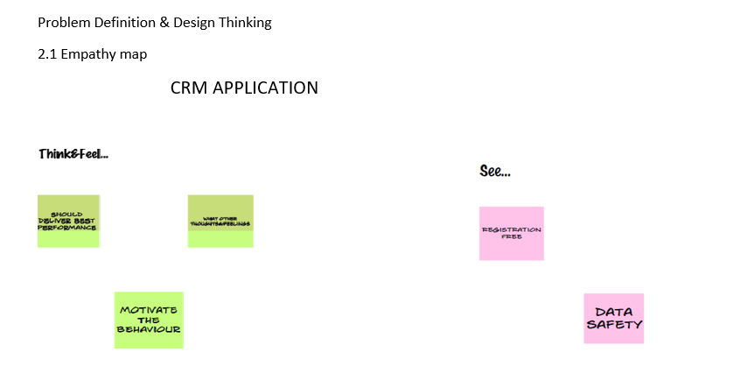



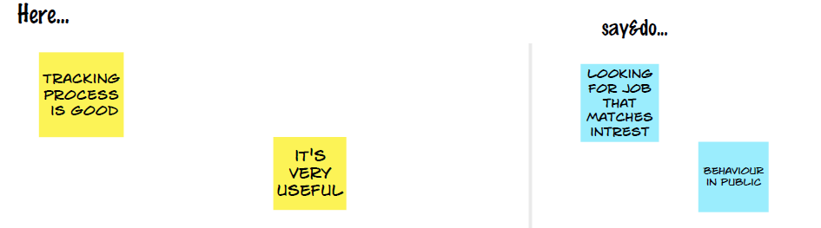

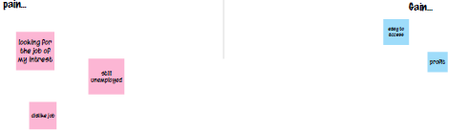

2.2 Ideation & Brainstorming Map

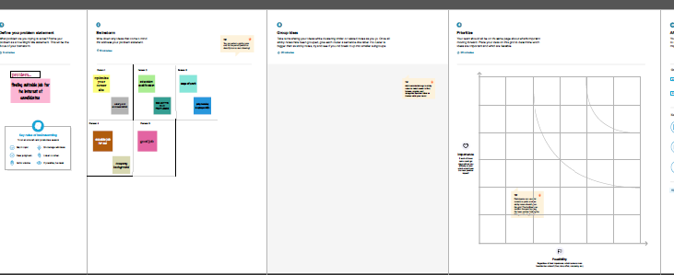

3 RESULT

3.1 Data Model:

|  |  |
| --- | --- |
| Object name | Field in the object |
| Obj 1 | Field lable data type  Candidate Custom Object |
| Obj 2 | Field lable data type  Custom1 Custom Object |
| Obj 3 | Field lable data type  Job Text |
| Obj 4 | Field lable data type  Job application Text |
| Obj 5 | Field lable data type  Recruiter Auto Number |
| Obj 6 | Field lable data type  location Text area |
|  |  |

3.2 Activity & Screenshot

The setup page will appear as below

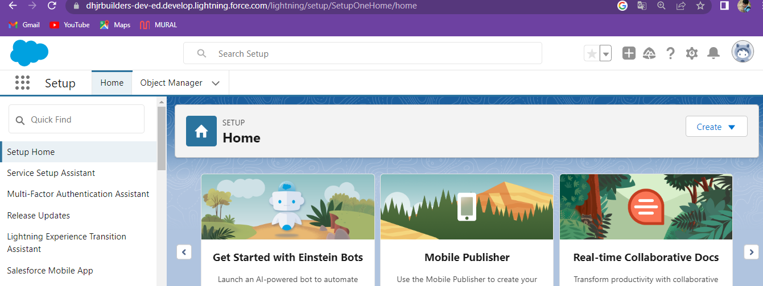

Create a custom object for Recruiter:

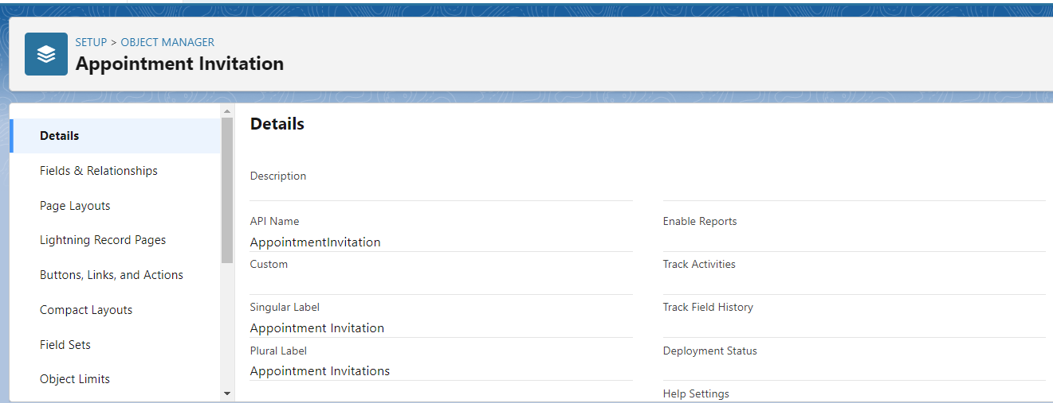

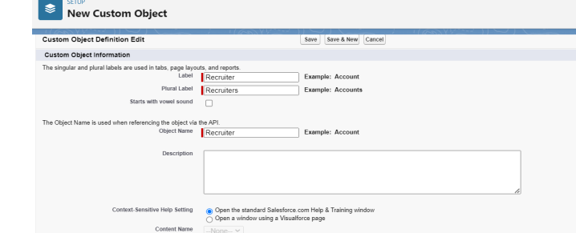

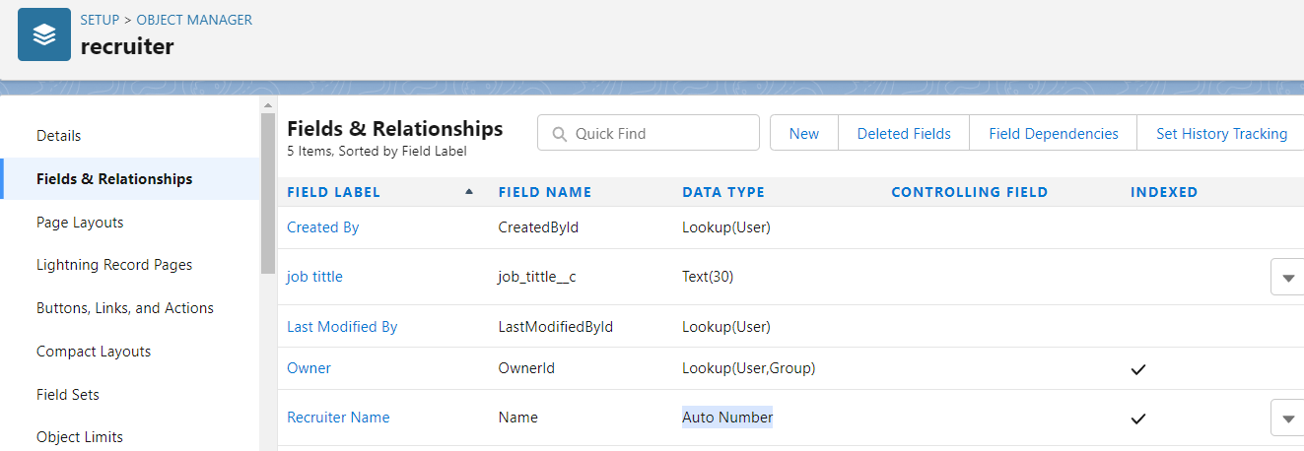

Activity 2:

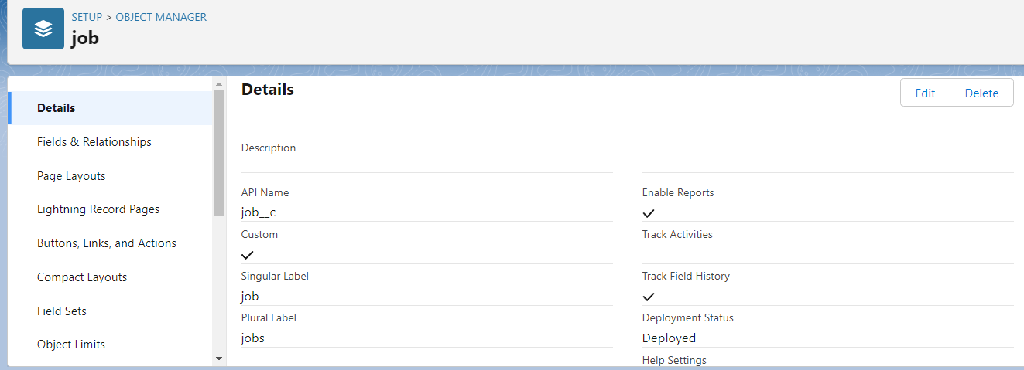

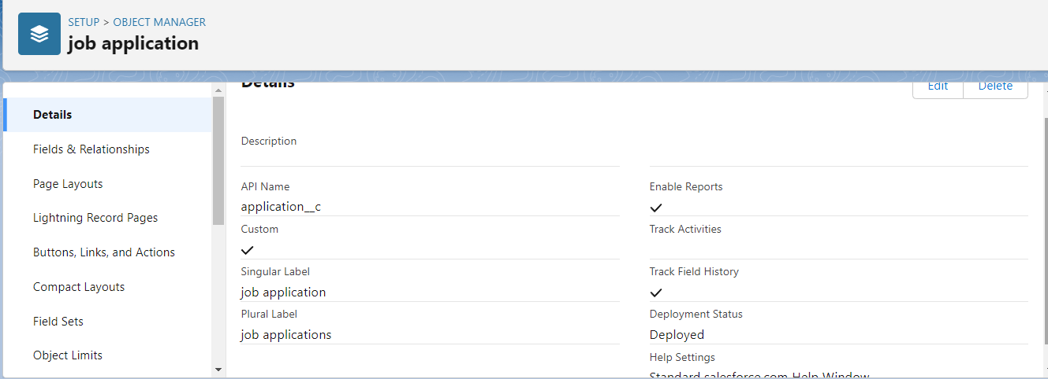

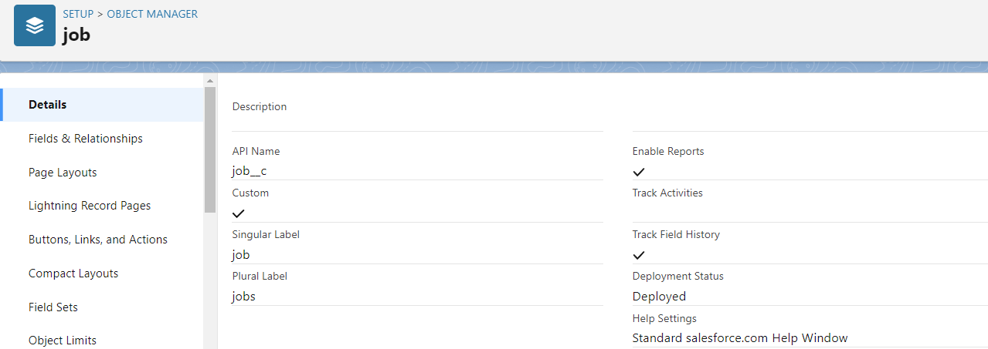

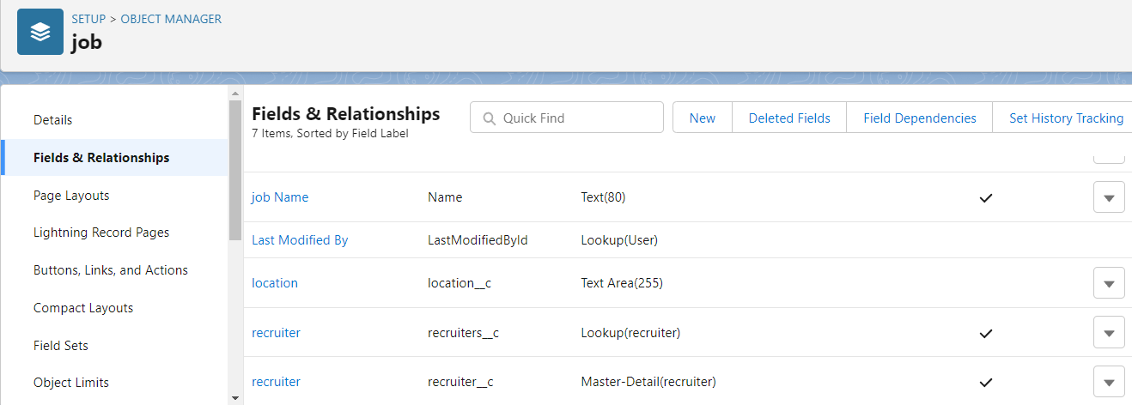

Create a tab

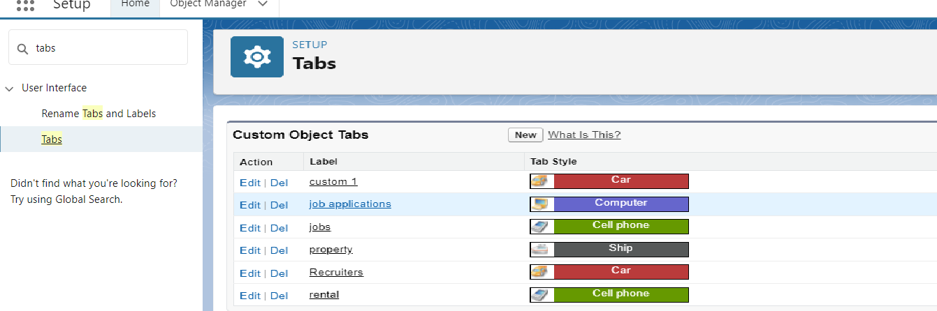

Create a custom profile

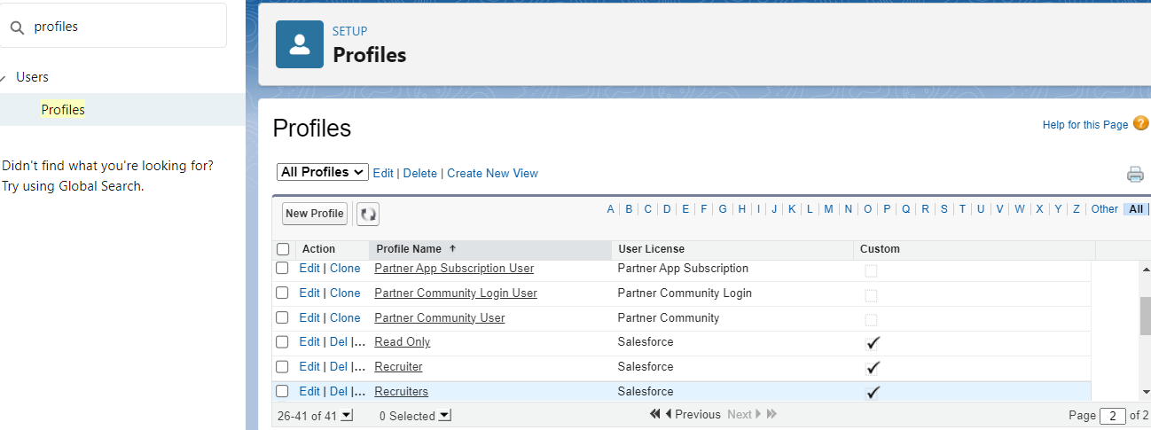

Create sales manager

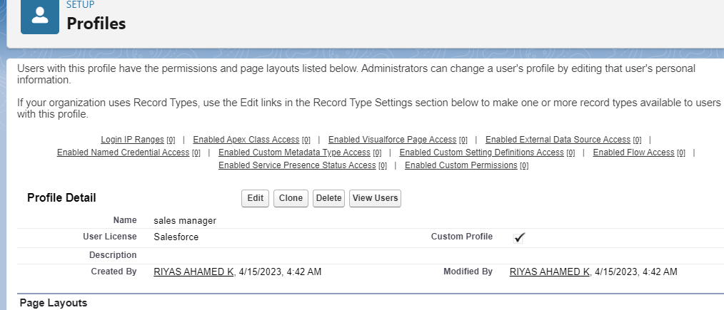

To Create a user:

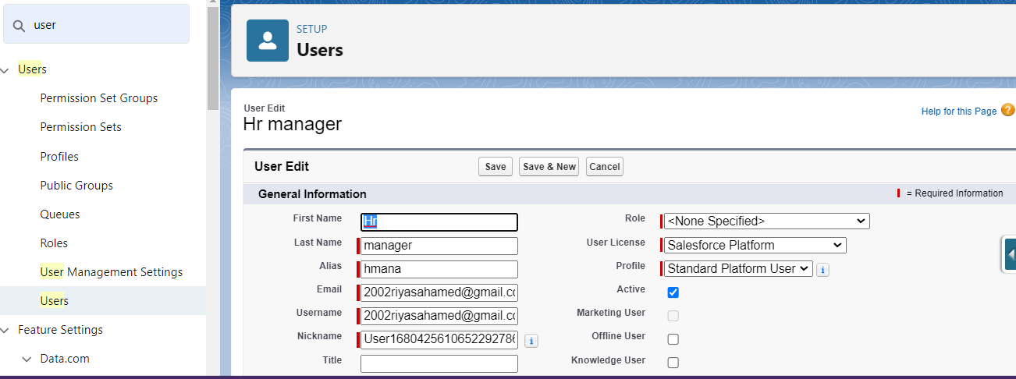

Activity 2:

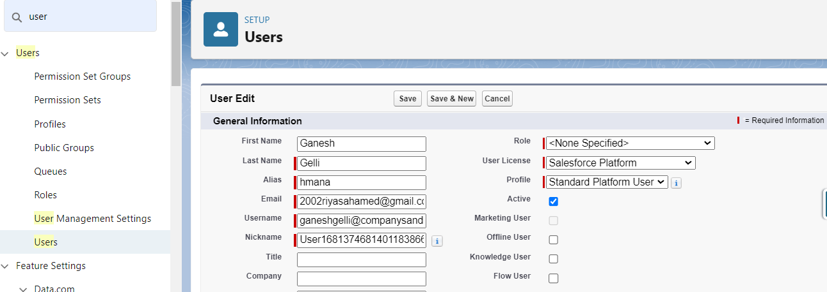

Create a sharing rule

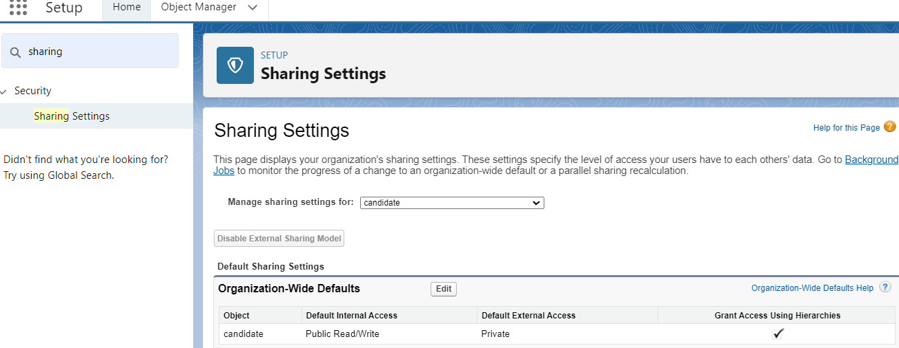

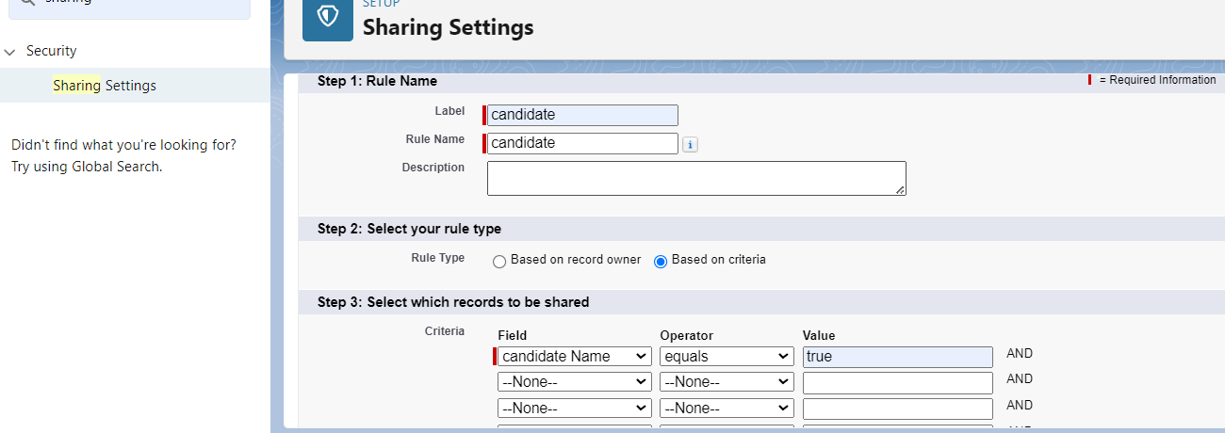

Create a report:

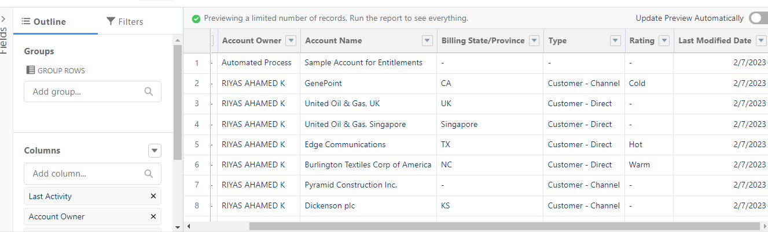

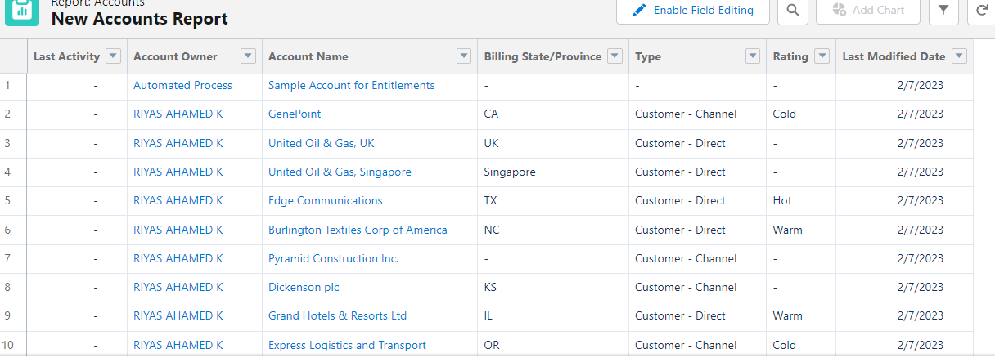

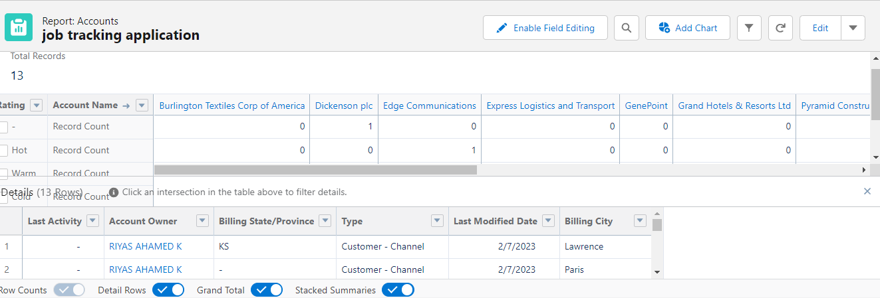

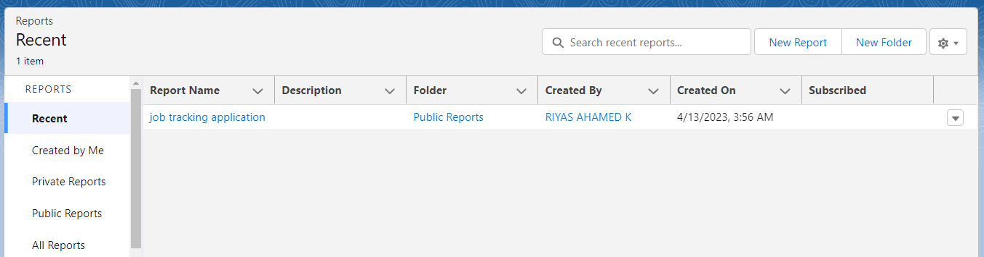

4 Trailhead Profile Public URL

Team Lead - https://trailblazer.me/id/raook

Team Member 1 –https://trailblazer.me/id/dhurn4

Team Member 2 –

Team Member 3-

**5 ADVANTAGES & DISADVANTAGES**

**ADVANTAGES**

1. This app helps the candidate to do wide search and track the right kind of job for his career improvement.
2. This app provides the facility to search the job online and saves his/her time.
3. Once the candidate completes his/her registration, app automatically send the job notifications as per the candidate’s job preference.
4. Enrolment fee is economical.

**DISADVANTAGES**

**`1.** There is no time limit given for the candidate’s job placement.

**2.** No pre-training process option is given.

**6 APPLICATIONS**

1. This app is mainly focused on job searching candidates .
2. This app can be used in companies also to find the right candidate for the vacancies available in their company.

**7** C**ONCLUSION**

This application is very helpful for those who search the right kind of job for their qualification. It provides very good job tracking option for the candidate. The candidate can view the record of placement. Everything in the app goes online so, the candidate can access this from anywhere.

**8 FUTURE SCOPE**

**This app** allows further expansion in their service for job searching like mobile app, tracking history , reminder for the interview , etc.

This app can be extended its service for the colleges for their students’ placement in the final year.

Pre-registration may be allowed before completing the course. Once they completes the course, this app can send the job notifications to their mail.